**Working procedure in Jira**

**Project name:daraz.com.bd**

1.we found a bug on daraz website that occur on the signup page.

* Open browser write daraz.com.bd and got to the url
* Click sign up/log in button

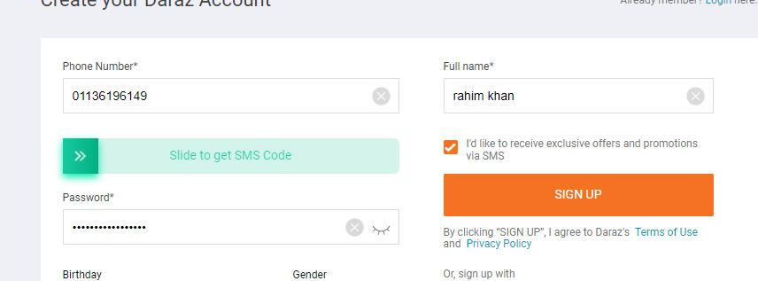

Fig.1

In figure 1 we fill all the fields but in the phone number fields we put the wrong phone number series

2. after filling all the input fields we swipe slide to get sms Code option

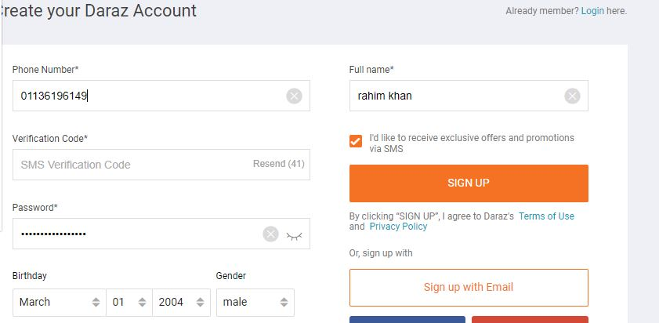

Fig.2

In figure 2 we accept an error message but we do not find it and its looks like there is no failure.

3. so we found a bug and now we can track the bug using the test management tool Jira. using this tool we can define the requirement, write test scenario, update the test case, report the bugs.

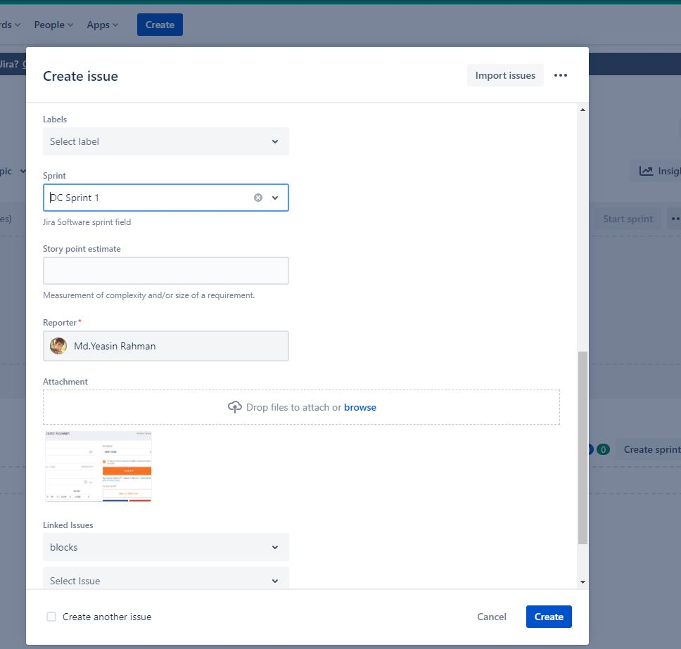

Fig.3

In figure 3 we create issue after entering the Jira tool for the developer

4. after creating an issue we assign it to a specific developer to fix it and we create sprint for that.

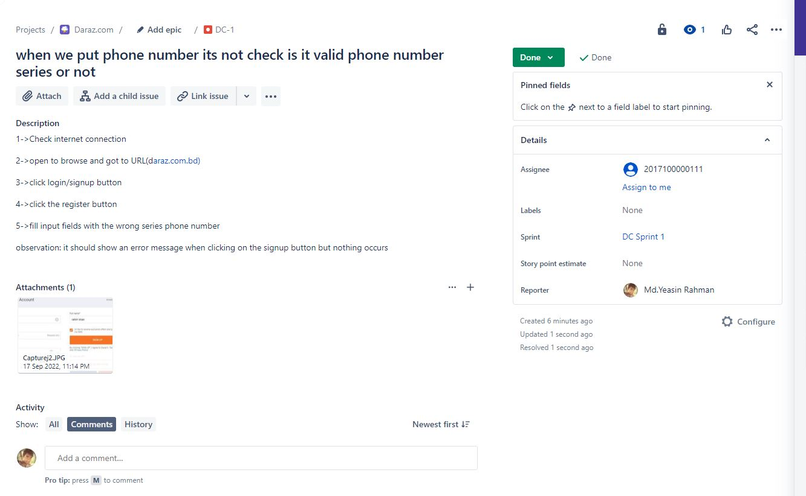

Fig.4

In figure 4 we can see that to whom we assign the task received an email for that bug and started his work to solve the bug

5. when the developer work on that time work is in progress mode

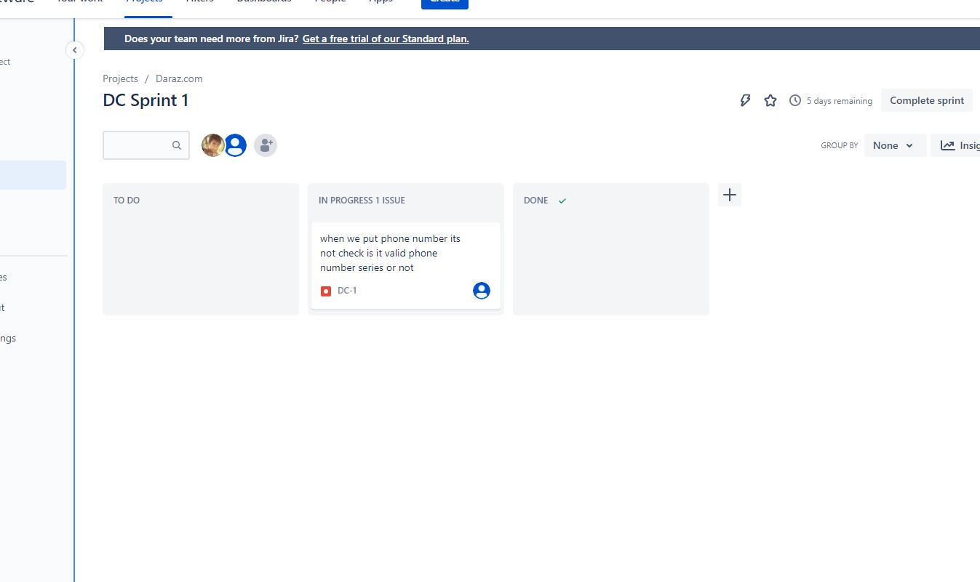

Fig.5

In figure 5 it indicates developer work on it and he tries to fix the bug

6.After fix the bug properly the issue is now in the “Done” phase.

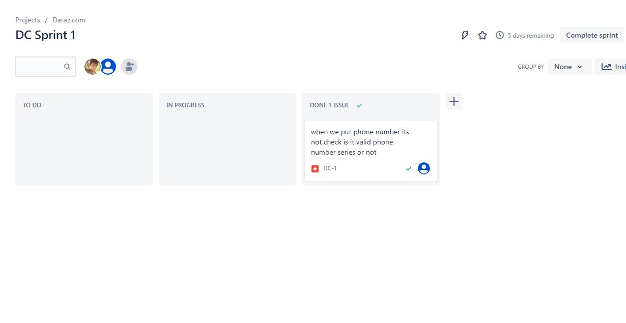

Fig.6